Machine Description | kioptrix level 2 is a purposely vulnerable training machine that mimics a small internet-facing web host. it runs apache, php and a legacy php-nuke installation with known input validation flaws. the service footprint is minimal so enumeration focuses on web content discovery and sql injection.
Target IP | 10.136.108.237
Vulnerability Name | PHP-Nuke SQL Injection (CVE-2006-5865)
Service / Version | TCP / 80 HTTP
CVSS Score / Severity | 9.8 Critical
Attack Vector | CVSS:3.1/AV:N/AC:L/PR:N/UI:N/S:U/C:H/I:H/A:H.
Proof Of Concept | STEP 1 – Host Discovery using Netdiscover  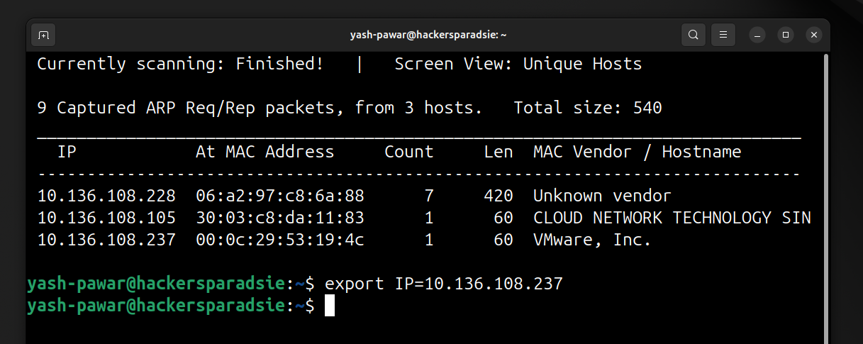  STEP 2 – Nmap scan for service and version  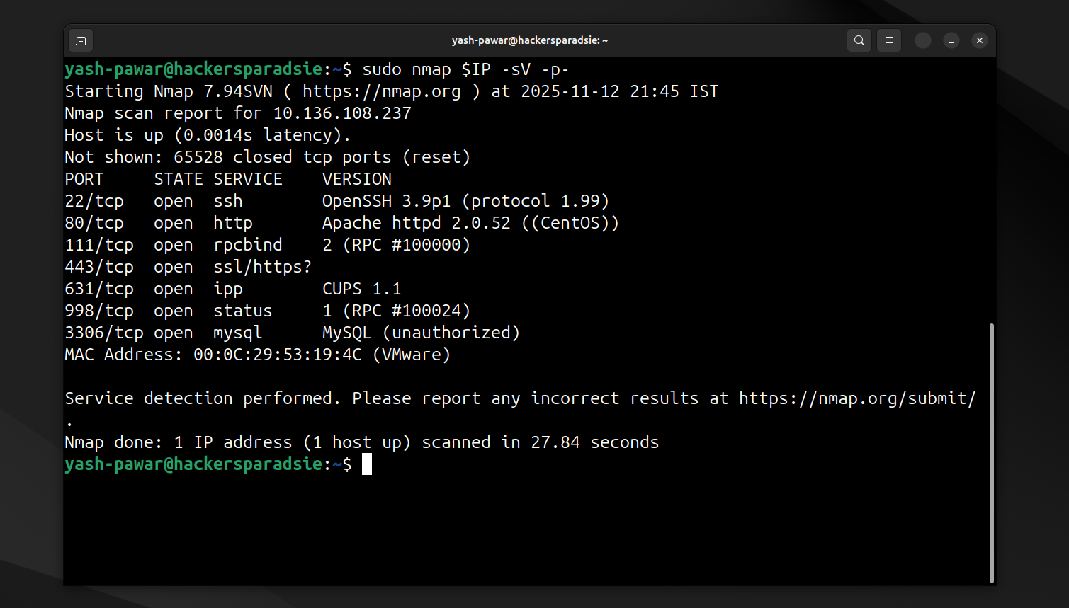  STEP 3 – Enumerating HTTP 80  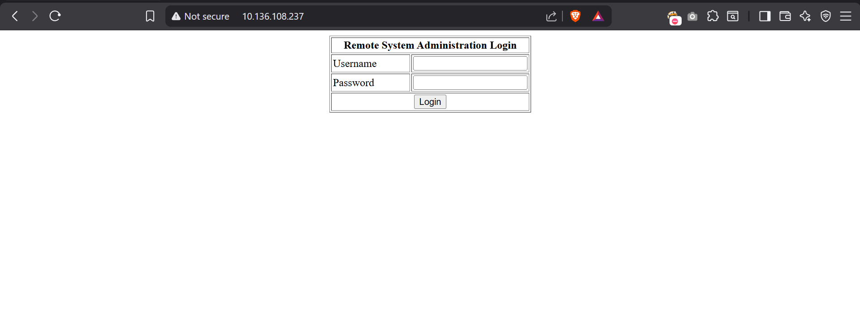  - Directories on server  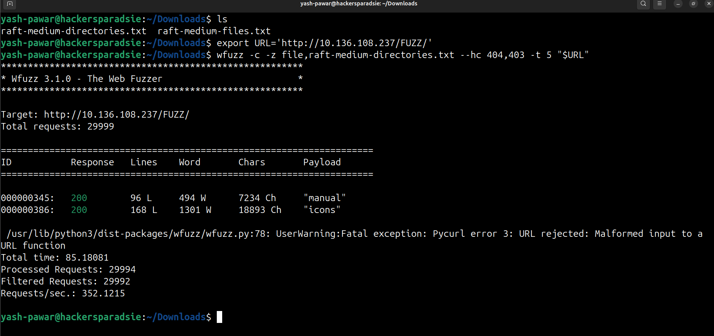  - Files on the server  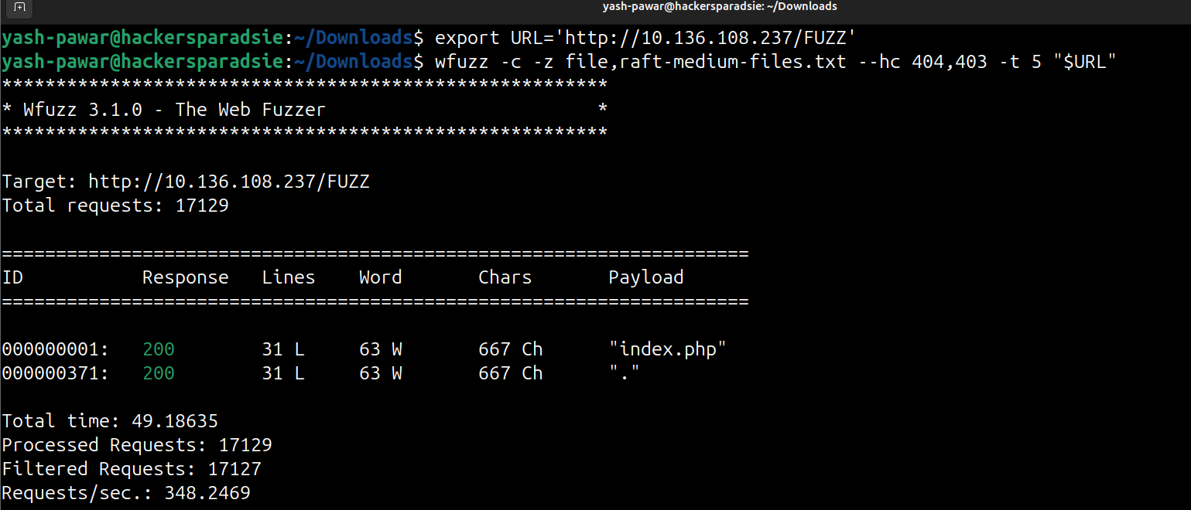  STEP 4 – Found SQL injection which gives auth bypass  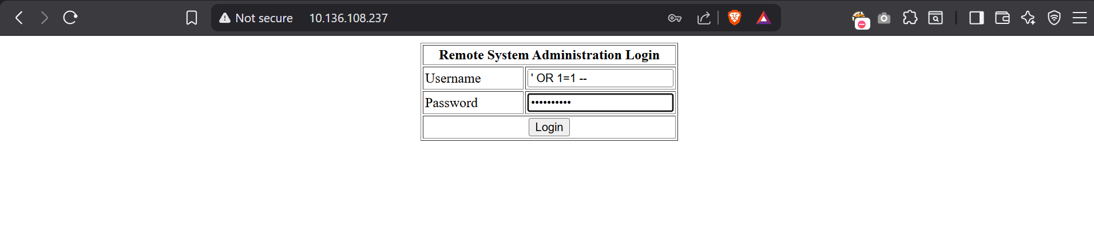  - Got login on the portal we have ping functionality on the portal  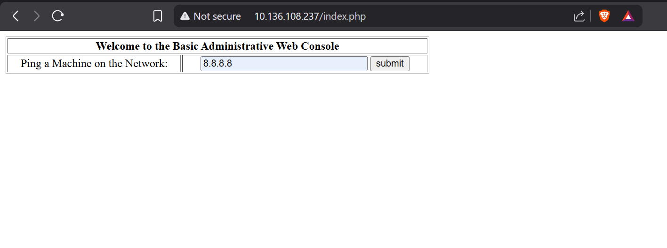  - Who gives us output on pingit.php but its redirected  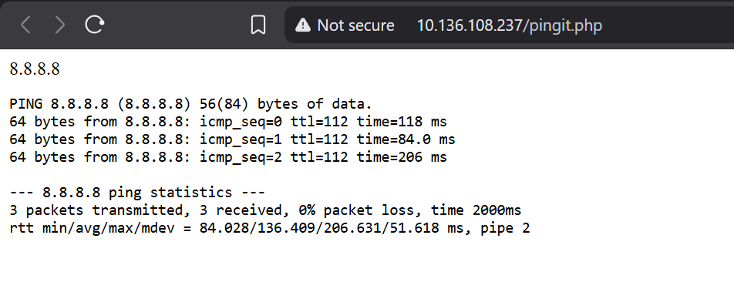  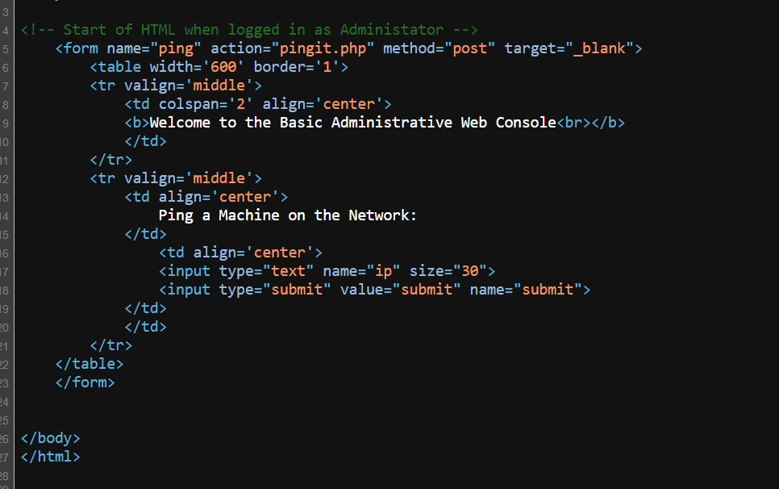  - Variable name : id  - Location of submit : pingit.php  - Method : post  STEP 5 – Lets try to intercept request on the burp suite craft a post request to directly to the /pingit.php  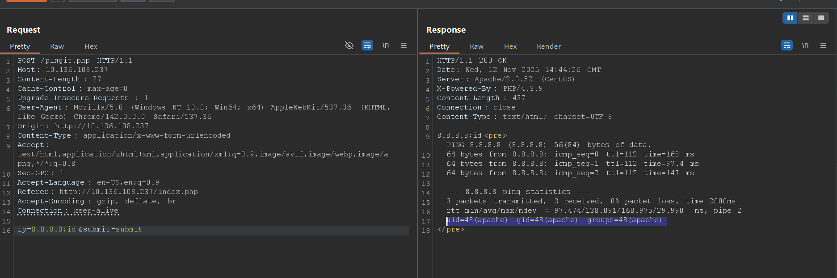  Here we got RCE on target  STEP 6 – Lets get bash reverse shell on net cat port 1234  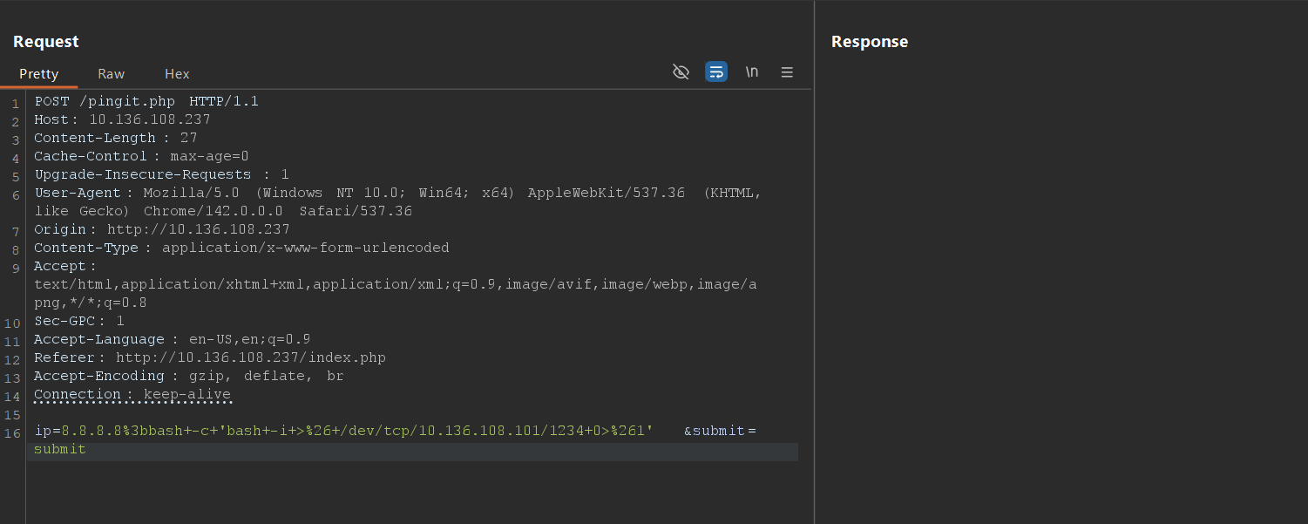  We got Reverse shell on netcat  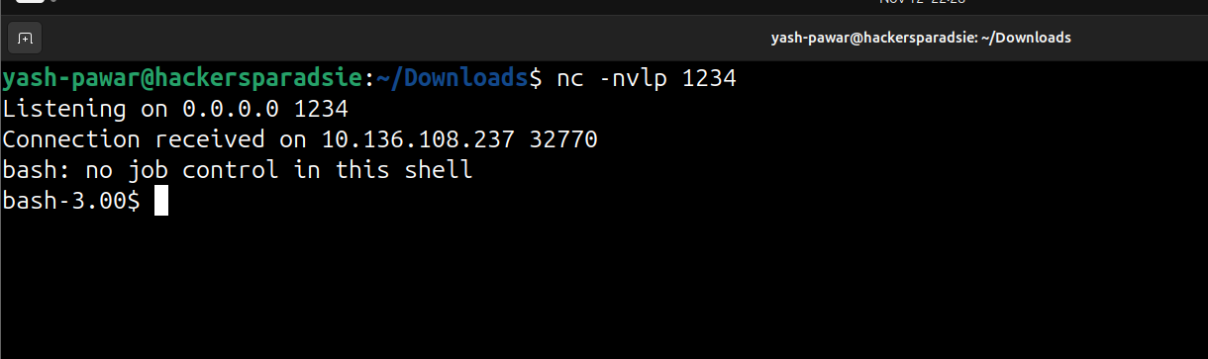  STEP 7 – Privilege Escalation  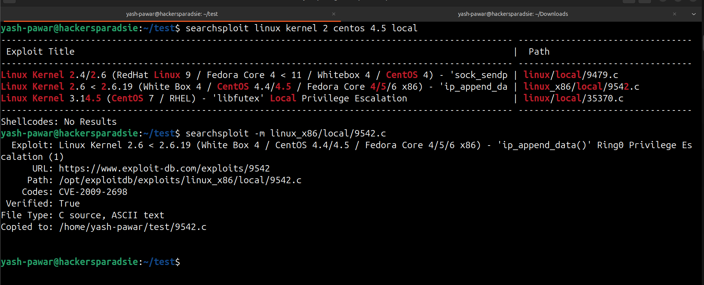  - We have exploit for kernel version lets send it to target using python server  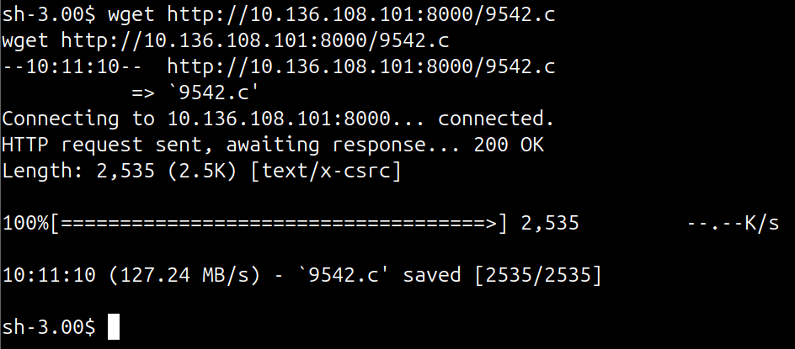  - Add executing +x permissions to file  - Compile the code  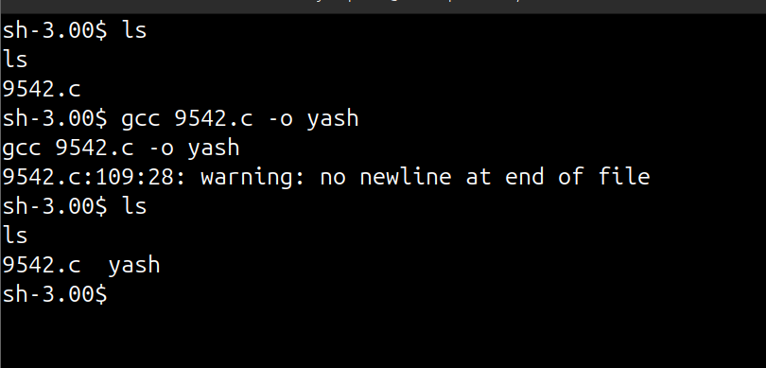  - Lets run the binary  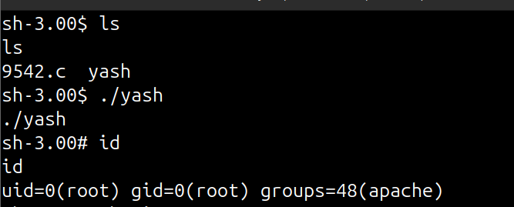  We got root privileges
Impact | - remote attacker can bypass authentication via SQL injection.  - Gain admin panel access and upload malicious PHP shell.  - Execute arbitrary commands leading to server compromise.  - Sensitive database credentials and user info exposed.
Remediation | - Apply latest PHP-Nuke patch addressing input sanitization flaws.  - Implement prepared statements or parameterized queries.  - Use web application firewall (WAF) to block malicious SQL payloads.  - Restrict admin interface access to internal network only.
Reference | - https://nvd.nist.gov/vuln/detail/CVE-2006-5865  - https://www.exploit-db.com/exploits/147  - https://www.securityfocus.com/bid/21129

